Answer manual for SPSS but not Excel. Need better answers and correct graphs from Excel:
Question 1:
Ans: The following output is produced, with Department 1, Department 2, and Department 3 (Department 4 omitted):
The dependent variable is Productivity. The independent variables are Teamwork, Jobknowl, Jobauthr, Wrkdyssk, and Recogawd. The three dummy variables are Department 1, Department 2, and Department 3.
Model ANOVA Table
R | R² | Adjusted-R² | SEE
.578 | .334 | .317 | .707

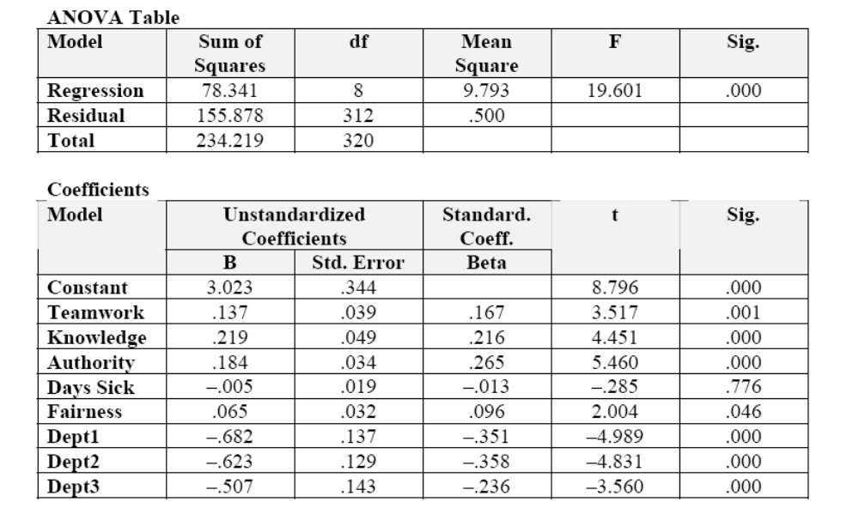

The results show that teamwork remains significantly associated with productivity improvement (p < .01). Although there are differences among departments that are associated with productivity, these differences do not affect the statistical significance of variables shown in Table 15.1. These factors further increase the adjusted R², which is now 31.7%.
The error term plot of shows a random pattern around (0,0):
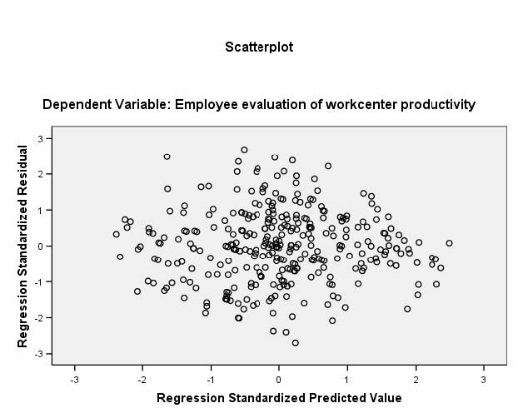

Question 2:
a. Briefly state your hypotheses.
Ans: This is a good exercise for getting students to clarify their thinking. For example, the rationale for hypothesizing the relationship between public complaints and the use of focus groups is, for example, that the former indicates a service problem and the use of focus groups furthers problem definition and solution generation. The rationale for including size and region is less obvious. Size may be correlated with resources (similar to budget increases), and focus groups require resources, though actually quite little. The variable Region is hard to justify, though many productivity improvement techniques seem to start in the West.
H0: There is no relationship between the use of focus groups and the interest of managers in obtaining citizen-based feedback [or any other independent variable], controlled for the effect of public complaints, budgets, size, and region [all other independent variables listed here].
HA: There is a relationship between the use of focus groups and the interest of managers in obtaining citizen-based feedback [or any other independent variable], controlled for the effect of public complaints, budgets, size, and region [all other independent variables listed here]
b. Provide a brief description of variables (univariate analysis). Also, examine the bivariate associations between Focus and Mgrint, Pubcompl, Budget, and Size. Examine the bivariate relationships that exist between all possible pairs of these variables.
Ans: This is straightforward, providing a write-up of the mean and frequency distributions of each of these variables. Many students want a template, which tells them what to write in an automatic fashion (“the mean is . . .”). Rather, I try to get them to search for conclusions (e.g., “about half the cities are small . . .”). For example, Univariate analysis of the index measure of focus groups shows that this variable varies from 0 to 20, with a mean of 10.11. About a quarter, 25.7%, have scores up to 4.0, and 25.7% have scores greater than or equal to 15.
The bivariate associations show strong correlations between the independent variables and the dependent variable. They also show a rather strong correlation between Budget and Mgrint (r = .659)
c. Examine whether Mgrint, Pubcompl, Budget, and Size are statistically associated with the use of focus groups. For this purpose, conduct a multiple regression in which the dependent variable is Focus and the independent variables are Mgrint, Pubcompl, Budget, and Size. What do you conclude? (You need not write up these results.)
The following result is obtained (R² =.910, t-test statistics in parentheses):

FOCUS = .482 + 2.211** MGRINT +.392 PUBCOMPL + 1.416* BUDGET + .893** SIZE
(6.93) (1.88) (2.61) (4.70)

whereby, *5% significant; **1% significant.

d. You now wish to include the effect of region in your analysis. To do this, you must make Region a dummy variable. Assume you wish to compare the effect of the different regions with Midwest. To make the dummy variables for the Northeast, South, and West, you must either recode the data for each region or enter the data manually. Through either of these techniques, add Northeast, South, and West to your model and rerun the analysis.
Ans: See results and write-up below.

e. Provide a complete write-up of the regression. (1) Identify which variables are significant and at what level. Identify the adjusted R² statistic (Is it a strong or weak association?). Also, discuss the β coefficients. What do you conclude? (2) Plot the standardized residuals against the standardized predicted values. What do you conclude? (3) To examine the possibility of multicollinearity, examine the bivariate correlations among the independent variables. What do you conclude? Given the significance of coefficients, is multicollinearity a problem here?

Ans: To examine the factors that affect the use of focus groups in cities, a survey was conducted that collected data about program performance as well as a range of factors that might affect it. These factors are city manager interest in productivity improvement, public complaints, changes in the budget, city size, and region.
Univariate analysis of the index measure of focus groups shows that this variable varies from 0 to 20, with a mean of 10.11. About a quarter, 25.7% have scores up to 4.0, and 25.7% have scores greater than or equal to 15.
The relationship between FOCUS and MGRINT is positive and r² = 0.904. The relationship between FOCUS and PUBCOMPL is also positive, and r² = .0667.
The results of the multiple regression are reported below. We examined the initial results for possible outliers and other problems of such as heteroscedasticity, nonlinearity, or multicollinearity, but found none. (If you see these problems, describe what was done to correct them. If you do not see such problems, note that.) The following independent variables are statistically significantly associated with effectiveness and efficiency of programs in cities managerial interest (p < .01) and size (p < .01). R²-adjusted is .912. The model is stated below (t-statistics in parentheses):
FOCUS = 1.216 + 2.347** MGRINT + 0.371 PUBCOMPL + 1.066 BUDGET
(7.091) (1.771) (1.739)
+ 0.723** SIZE−1.576 NORTHEAST + 0.402 SOUTH
(3.161) (–1.793) (0.357)
−0.162 WEST
(–0.150)
whereby, *p < 0.05 significance; **p < 0.01 significance.
Model Summaryª
Model | R | R² | Adjusted R² | Standard Error of the Estimate
1 | .965^{b} | .930 | .912 | 1.84232
ªDependent variable: perfm
^{b}Predictors: (constant), west, mgrint, northeast, pubcompl, south, size, budget

ANOVAª
Model |  | Sum of Squares | df | Mean Square | F | Significance
1 | Regression Residual Total | 1223.901  91.642  1315.543 | 7 27 34 | 174.843 3.394 | 51.513 | .000^{b}
b. ªDependent Variable: perfm
^{b}Predictors: (constant), west, mgrint, northeast, pubcompl, south, size, budget

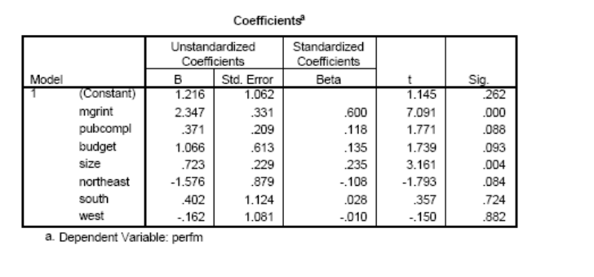

Plot of the standardized residuals against the standardized predicted values:

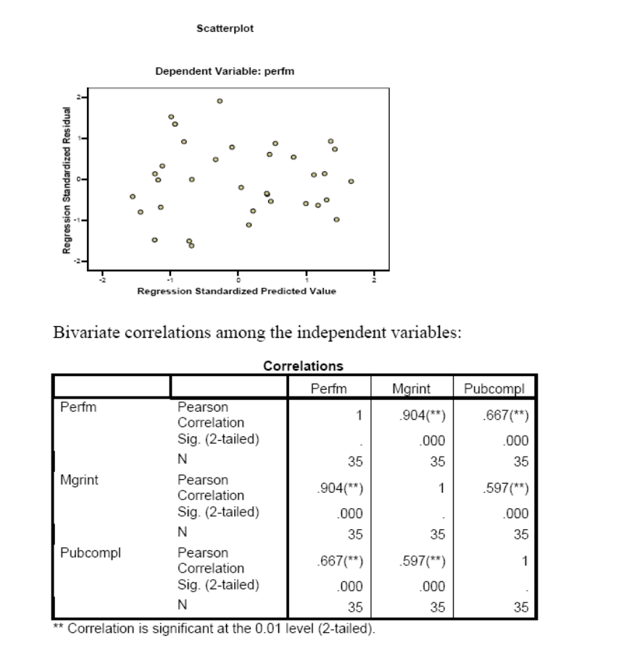

Question 3:
a. You wish to evaluate whether the new law has been effective. You model the effect on fatalities and explore the possibility of autocorrelation in time series data. Hence, Fatal = f(Short, Long, Jailtime). Run the regression analysis, and examine the error term for autocorrelation. Specifically, examine the Durbin-Watson test statistic. What do you conclude?
The model Fatal = f(Short, Long, Jailtime) shows autocorrelation: the Durbin-Watson test statistic is 0.814 (with N = 16 and k = 3, dl = 0.86 and du = 1.73).
b. Now, take the trend variable into account: Add Year as an independent variable to your list. Again, note the Durbin-Watson statistic. What do you conclude about adding the trend variable? Provide a complete write-up.
When the variable Year is added (hence, Fatal = f(Short, Long, Jailtime, Year), the Durbin-Watson test statistic is 2.27, suggesting no autocorrelation. The variable Long is significant (p < .05).

